**DAILY ONLINE ACTIVITIES SUMMARY**

|  |  |  |  |  |  |  |  |  |
| --- | --- | --- | --- | --- | --- | --- | --- | --- |
| **Date:** | **18-5-2020** | | | | | **Name:** | **Likhitha.M** | |
| **Sem & Sec** | **6th sem ‘A’** | | | | | **USN:** | **4al17cs046** | |
| **Online Test Summary** | | | | | | | | |
| **Subject** | | **Cryptography network security & cyber laws** | | | | | | |
| **Max. Marks** | | **60** | | **Score** | | | **41** | |
| **Certification Course Summary** | | | | | | | | |
| **Course** | **Python for machine learning** | | | | | | | |
| **Certificate Provider** | | | **Great learning** | | **Duration** | | | **1 week** |
| **Coding Challenges** | | | | | | | | |
| **Problem Statement:**   1. Using methods charAt() & length() of String class, write a program to print the frequency of each character in a string.   “Hello friend   1. Write down a java program to print even and odd numbers series respectively from two threads: t1 and t2 synchronizing on a shared object   Let t1 print message “ping — >” and t2 print message “,—-pong”.  Take as command line arguments, the following inputs to the program: Sleep Interval for thread t1 Write down a java program to print even and odd numbers series respectively from two threads: t1 and t2 synchronizing on a shared object | | | | | | | | |
| **Status: completed** | | | | | | | | |
| **Uploaded the report in Github** | | | | | **yes** | | | |
| **If yes Repository name** | | | | | **https://github.com/likhithaMantaral/Daily-status** | | | |
| **Uploaded the report in slack** | | | | | **yes** | | | |

Online test Details:

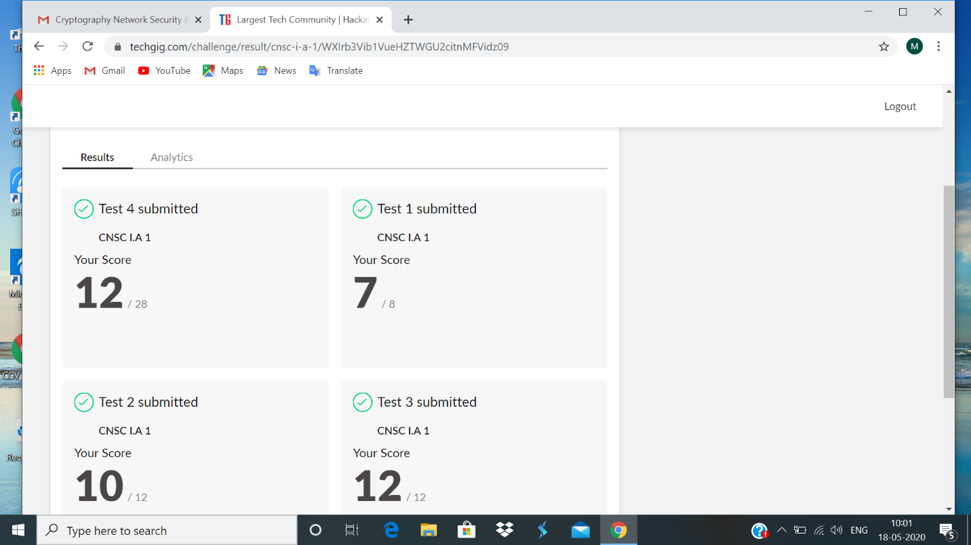

Certification Course Details:

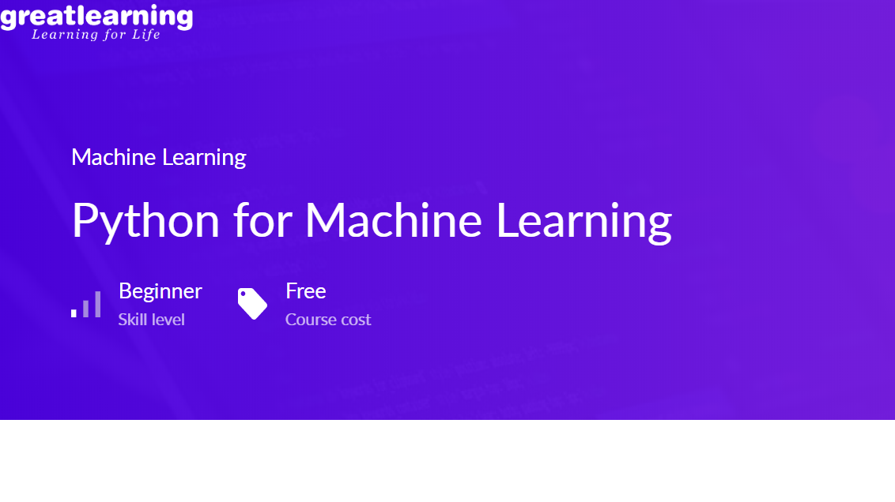

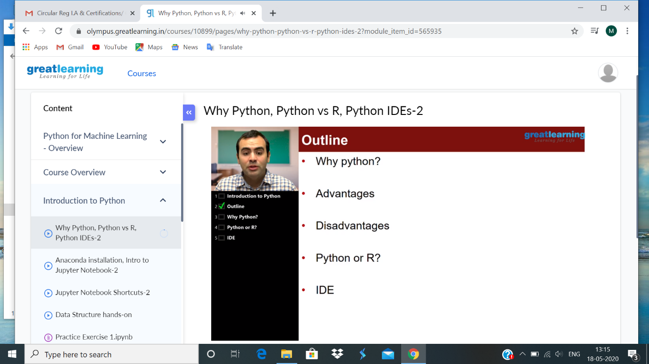

PYTHON FOR MACHINE LEARNING:

In todays class learnt why python is used, what are the advantages, disadvantages, python or R, IDE.Python is easy to implement. Development time is quick, easy to implement, debugging is straight forward, python is a open source. There are many popular IDE’s: pycharm, jupyter note books and spiders. It is possible to use python without IDE. Commun ication of ideas is easy in jupyter. Pyhton is not restricted to data science. Python is an open source.

**Coding challenge:**

**1.** import java.util.Scanner;

public class StringOperator

{

public static void main(String args[])

{

int i;

String str;

int counter[] = new int[256];

Scanner in = new Scanner(System.in);

System.out.print("Enter a String : ");

str=in.nextLine();

for (i = 0; i < str.length(); i++) {

counter[(int) str.charAt(i)]++;

}

// Print Frequency of characters

for (i = 0; i < 256; i++) {

if (counter[i] != 0) {

System.out.println("The character " + (char) i + " :" + counter[i] + " times");

}

}

}

}

2.

public class PingPong extends Thread {

static StringBuilder object = new StringBuilder("");

public static void main(String[] args) throws InterruptedException {

Thread t1 = new PingPong();

Thread t2 = new PingPong();

t1.setName("\nping");

t2.setName(" pong");

t1.start();

t2.start();

}

@override

public void run() {

working();

}

void working() {

while (true) {

synchronized (object) {

try {

System.out.print(Thread.currentThread().getName());

object.notify();

object.wait();

} catch (InterruptedException e) {

e.printStackTrace();

}

}

}

}

}